--------------------------------------------------------------------------------------------------------------------------

**Assignment 2: Retrieve data using join with where clause**

**Sample table1: salesman**

-salesman_id

-name

-city

-commission

**Sample table2: customer**

-customer_id

cust_name

-city

-grade

-salesman_id

**Sample table3: orders**

-ord_no

purch_amt

-ord_date

-customer_id

-salesman_id

Create Table salesman

(

salesman_id int NOT NULL Primary key,

name nvarchar(50) NOT NULL,

city nvarchar(20) NOT NULL,

commission int NOT NULL,

)

Create Table customer

(

customer_id int NOT NULL Primary key,

cust_name nvarchar(50) NOT NULL,

city nvarchar(20) NOT NULL,

grade int,

salesman_id int,

Foreign Key (salesman_id) References salesman(salesman_id)

)

Create Table orders

(

ord_no int NOT NULL Primary Key,

purch_amt money NOT NULL,

ord_date date NOT NULL,

customer_id int NOT NULL,

salesman_id int NOT NULL,

Foreign Key (customer_id) References customer(customer_id),

Foreign Key (salesman_id) References salesman(salesman_id),

)

Inserting values to the column:

Insert Into salesman values

(5001, 'James', 'New York', 15),

(5002, 'Nail', 'Paris', 13),

(5003, 'Pit', 'London', 11),

(5004, 'Lyon', 'Paris', 14),

(5005, 'Paul', 'Rome', 13),

(5006, 'Lauson', 'San Fransisco', 12),

(5007, 'Harry', 'Amsterdam', 16),

(5008, 'Albus', 'Cape Town', 12);

Insert Into customer values

(3001, 'Nick', 'New York', 100, 5001),

(3002, 'Brad Davis', 'New York', 200, 5001),

(3003, 'Graham', 'California', 200, 5002),

(3004, 'Julian', 'London', 300, 5002),

(3005, 'Fabian', 'Paris', 300, 5004),

(3006, 'Cameron', 'Berlin', 100, 5006),

(3007, 'Jozy', 'Moscow', 200, 5005),

(3008, 'Brad Guzan', 'London', NULL , 5003),

(3009, 'Tony', 'Cape Town', 300, 5003),

(3010, 'Peter', 'San Fransisco', NULL , 5006);

Insert Into orders values

(7001, 150.5, '2012-10-05', 3003, 5002),

(7002, 270.65, '2012-09-10', 3008, 5003),

(7003, 65.26, '2012-10-05', 3001, 5001),

(7004, 110.5, '2012-08-17', 3006, 5006),

(7005, 948.5, '2012-09-10', 3003, 5002),

(7006, 2400.6, '2012-07-27', 3002, 5001),

(7007, 5760, '2012-09-10', 3001, 5001),

(7008, 1983.43, '2012-10-10', 3005, 5004),

(7009, 2480.4, '2012-10-10', 3006, 5006),

(7010, 250.45, '2012-06-27', 3004, 5002),

(7011, 75.29, '2012-08-17', 3007, 5005),

(7012, 3045.6, '2012-04-25', 3001, 5001);

1. write a SQL query to find the salesperson and customer who reside in the same city.

Return Salesman, cust_name and city

Select **name as Salesman,cust_name,customer.city**

from salesman

INNER JOIN customer

**ON salesman.city=customer.city**

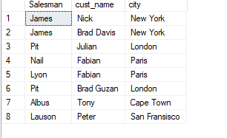

**2. write a SQL query to find those orders where the order amount exists between 500**

**and 2000. Return ord_no, purch_amt, cust_name, city**

**Select ord_no, purch_amt, cust_name, city**

from customer

INNER JOIN Orders

ON customer.customer_id=orders.customer_id

**where purch_amt between 500 and 2000**

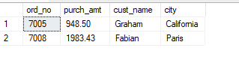

**3. write a SQL query to find the salesperson(s) and the customer(s) he represents.**

**Return Customer Name, city, Salesman, commission**

**Select cust_name as [Customer Name],customer.city,name as Salesman,Commission**

from salesman

INNER JOIN customer

**ON salesman.salesman_id= customer.salesman_id**

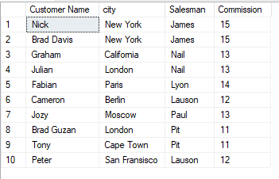

**4. write a SQL query to find salespeople who received commissions of more than 12**

**percent from the company. Return Customer Name, customer city, Salesman,**

**commission.**

**Select cust_name as [Customer Name],customer.city as [Customer City],name as Salesman,Commission**

from salesman

INNER JOIN customer

ON salesman.salesman_id= customer.salesman_id

**where commission>12;**

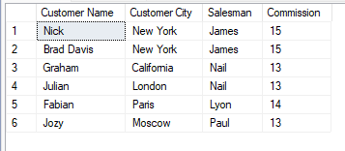

**5. write a SQL query to locate those salespeople who do not live in the same city where**

**their customers live and have received a commission of more than 12% from the**

**company. Return Customer Name, customer city, Salesman, salesman city,**

**commission**

**Select cust_name as [Customer Name],customer.city as [Customer City],name as Salesman,**

salesman.city as [Salesman City],Commission

from salesman

INNER JOIN customer

ON salesman.salesman_id= customer.salesman_id

**where salesman.city!=customer.city and commission>12;**

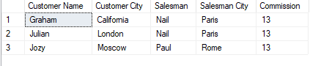

**6. write a SQL query to find the details of an order. Return ord_no, ord_date,**

**purch_amt, Customer Name, grade, Salesman, commission**

**Select ord_no, ord_date,purch_amt, cust_name as [Customer Name], Grade,**

name as Salesman , Commission

from Orders

INNER JOIN customer

ON customer.customer_id=orders.customer_id

INNER JOIN salesman

**ON salesman.salesman_id= customer.salesman_id**

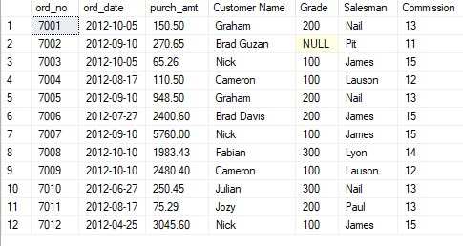

**7. Write a SQL statement to join the tables salesman, customer and orders so that the**

**same column of each table appears once and only the relational rows are returned.**

**Select salesman.salesman_id,Name,salesman.city,commission,customer.customer_id,cust_name,grade,**

ord_no , purch_amt,ord_date

from salesman

INNER JOIN customer

ON salesman.salesman_id= customer.salesman_id

INNER JOIN Orders

ON customer.customer_id=orders.customer_id

**order by salesman_id**

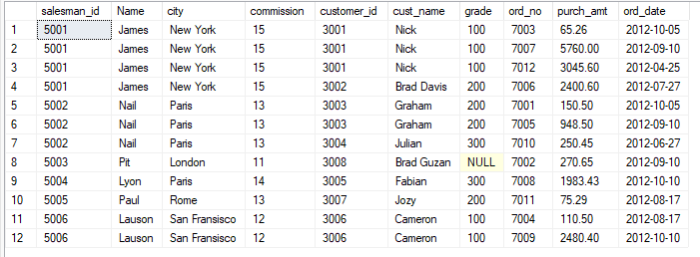

**8. write a SQL query to display the customer name, customer city, grade, salesman,**

**salesman city. The results should be sorted by ascending customer_id.**

**Select cust_name as [Customer Name],customer.city as [Customer City],Grade,Name as Salesman ,**

salesman.city as [Salesman City]

from customer

INNER JOIN salesman

ON salesman.salesman_id=customer.salesman_id

**order by customer_id**

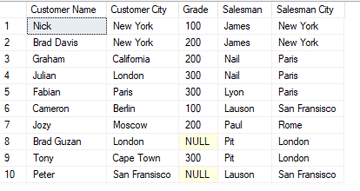

**9. write a SQL query to find those customers with a grade less than 300. Return**

**cust_name, customer city, grade, Salesman, salesmancity. The result should be**

**ordered by ascending customer_id.**

**Select cust_name as [Customer Name],customer.city as [Customer City],Grade,Name as Salesman ,**

salesman.city as [Salesman City]

from customer

INNER JOIN salesman

ON salesman.salesman_id=customer.salesman_id

where grade<300

**order by customer_id**

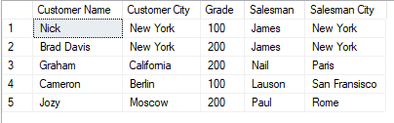

**10. Write a SQL statement to make a report with customer name, city, order number,**

**order date, and order amount in ascending order according to the order date to**

**determine whether any of the existing customers have placed an order or not**

**Select cust_name as [Customer Name],customer.city as [Customer City],ord_no as [Order Number],**

ord_date as [Order Date],Purch_amt as [Order Amount]

from customer

Left Outer JOIN orders

ON orders.customer_id=customer.customer_id

**order by ord_date**

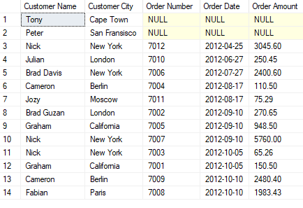

**11. Write a SQL statement to generate a report with customer name, city, order number,**

**order date, order amount, salesperson name, and commission to determine if any of**

**the existing customers have not placed orders or if they have placed orders through**

**their salesman or by themselves**

**Select cust_name as [Customer Name],customer.city as [Customer City],ord_no as [Order Number],**

ord_date as [Order Date],Purch_amt as [Order Amount],name as [Salesman Name],Commission

from customer

Left Outer JOIN orders

ON customer.customer_id=orders.customer_id

Left Outer JOIN salesman

ON customer.salesman_id=salesman.salesman_id

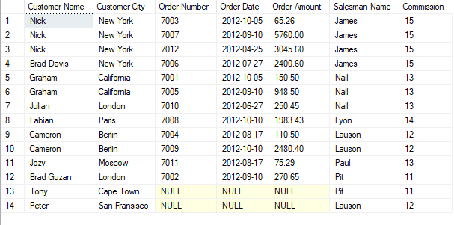

**12. Write a SQL statement to generate a list in ascending order of salespersons who**

**work either for one or more customers or have not yet joined any of the customers**

**SELECT name as [Salesman Name],cust_name as [Customer Name]**

FROM salesman s

LEFT OUTER JOIN customer c

ON s.salesman_id=c.salesman_id

**ORDER BY s.salesman_id ASC;**

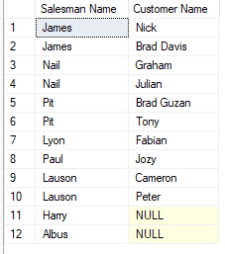

**13. write a SQL query to list all salespersons along with customer name, city, grade,**

**order number, date, and amount.**

**SELECT name as [Salesman Name],cust_name as [Customer Name],customer.city,Grade,ord_no as [Order Number],**

ord_date as [Date],purch_amt as [Amount]

FROM salesman

Left Outer JOIN customer

ON salesman.salesman_id=customer.salesman_id

Left Outer JOIN orders

**ON customer.customer_id=orders.customer_id**

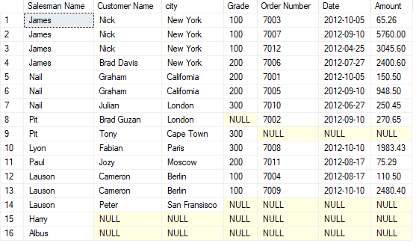

**14. Write a SQL statement to make a list for the salesmen who either work for one or**

**more customers or yet to join any of the customers. The customer may have placed,**

**either one or more orders on or above order amount 2000 and must have a grade, or**

**he may not have placed any order to the associated supplier.**

**SELECT s.salesman_id,name as [Salesman Name],s.city,s.commission,cust_name as [Customer Name],o.purch_amt as [Order Amount],c.Grade**

FROM salesman s

LEFT OUTER JOIN customer c

ON s.salesman_id=c.salesman_id

LEFT OUTER JOIN orders o

ON c.customer_id=o.customer_id

**where o.purch_amt>=2000 and c.Grade is not null**

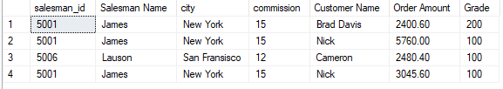

**15. Write a SQL statement to generate a list of all the salesmen who either work for one**

**or more customers or have yet to join any of them. The customer may have placed**

**one or more orders at or above order amount 2000, and must have a grade, or he**

**may not have placed any orders to the associated supplier.**

**SELECT s.salesman_id,name as [Salesman Name],s.city,s.commission,cust_name as [Customer Name],o.purch_amt as [Order Amount],c.Grade**

FROM salesman s

LEFT OUTER JOIN customer c

ON s.salesman_id=c.salesman_id

LEFT OUTER JOIN orders o

ON c.customer_id=o.customer_id

**where o.purch_amt>=2000 and c.Grade is not null**

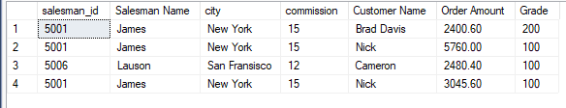

**16. Write a SQL statement to generate a report with the customer name, city, order no.**

**order date, purchase amount for only those customers on the list who must have a**

**grade and placed one or more orders or which order(s) have been placed by the**

**customer who neither is on the list nor has a grade.**

**Select cust_name as [Customer Name],customer.city , ord_no as [Order Number],ord_date as [Order_date],**

purch_amt as [Purchase Amount]

FROM customer

FULL OUTER JOIN orders

ON customer.customer_id= orders.customer_id

**AND customer.grade IS NOT NULL;**

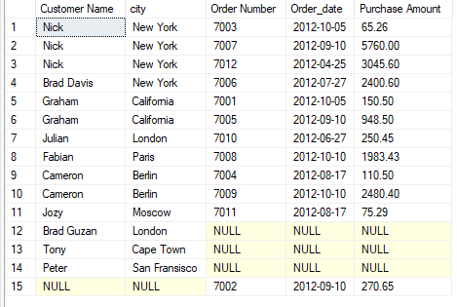

**17. Write a SQL query to combine each row of the salesman table with each row of the**

**customer table**

**SELECT \***

FROM salesman s

**CROSS JOIN customer c;**

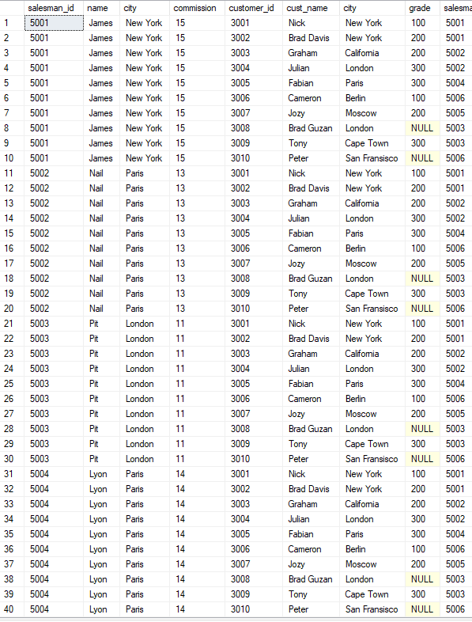

**18. Write a SQL statement to create a Cartesian product between salesperson and**

**customer, i.e. each salesperson will appear for all customers and vice versa for that**

**salesperson who belongs to that city**

**SELECT s.name AS Salesman,**

c.cust_name AS [Customer Name]

FROM salesman s

CROSS JOIN customer c

**WHERE s.city IS NOT NULL;**

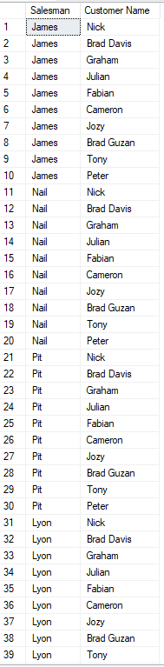

**19. Write a SQL statement to create a Cartesian product between salesperson and**

**customer, i.e. each salesperson will appear for every customer and vice versa for**

**those salesmen who belong to a city and customers who require a grade**

**SELECT s.name AS "Salesman", c.cust_name AS "Customer Name"**

FROM salesman s

CROSS JOIN customer c

WHERE s.city IS NOT NULL

**AND c.grade IS NOT NULL;**

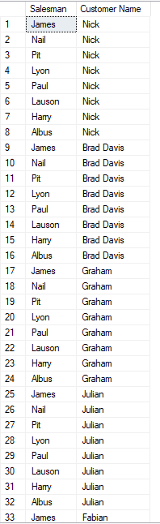

**20. Write a SQL statement to make a Cartesian product between salesman and**

**customer i.e. each salesman will appear for all customers and vice versa for those**

**salesmen who must belong to a city which is not the same as his customer and the**

**customers should have their own grade**

**SELECT s.name AS "Salesman",c.cust_name AS "Customer Name"**

FROM salesman s

CROSS JOIN customer c

WHERE s.city IS NOT NULL

AND s.city != c.city

**AND c.grade IS NOT NULL;**

